Direct-drive, single inlet centrifugal fans with backwards-curved high-performance centrifugal impellers made of composite material, based on a GreenTech EC external rotor motor with integrated control electronics.
One-piece impeller made of high-strength, glass-fiber reinforced composite material. 5 backward-curved and twisted 3D blades optimized in terms of strength. Blade inlet with rounded flow contour and profile tapered toward the rear to the blade outlet. Corrugated cover plate for optimum filling level. Flow-optimized inlet ring made of composite material with pressure test nipple.
Motor-impeller in accordance with DIN ISO 21940, statically and dynamically balanced on two planes to balancing grade G 6.3.
GreenTech EC external rotor motors achieve or exceed the efficiency specifications in accordance with efficiency class IE5 (IEC TS 60034-30-2:2016), magnets without the use of rare earths, maintenance-free ball bearings with long-term lubrication, theoretical nominal service life of at least 40,000 operating hours.
Soft start, integrated current limitation, automatic resonance detection (from an input power of 2kW), extended voltage input 1~200-277 V, 50/60 or 3~380-480 V, 50/60 Hz. The fan can be used with all standard power supply networks with unaltered air performance. Integrated control electronics, low-noise commutation logic; 100% speed control; all fans have an RS485/MODBUS RTU interface, no shielded cables are required for the power supply. All 1~ types feature integrated active PFC (Power Factor Correction) to reduce disturbing harmonic content. Terminal box made of aluminum/plastic with easily accessible connection area, environment-resistant cable glands.

Version for wall mounting:
Ready-to-install support bracket version intended for wall mounting (size 280 to 630). Support structure made of bent round steel or steel pipe, welded and coated in black. Mounting plate made of Sendzimir galvanized sheet steel.
Ready-to-install module version intended for wall mounting (size 310 to 630). Support structure made of bent round steel or steel pipe, welded and coated in black. Air guide module mounted on the pressure side, made of four aerodynamically shaped, Sendzimir galvanized sheet steel segments.
Inlet ring made of composite material with pressure test nipple. Installation position with horizontal motor shaft and vertical motor shaft with rotor on bottom. Vertical installation position with rotor on top on request.
Any work required for isolation from structure-borne noise is to be performed by the customer.
The fan satisfies the applicable EMC guidelines and requirements with regard to harmonic effects (see applicable data sheet for specific figures).
Documentation and marking in accordance with the applicable EU directives.
Reliable performance data, air performance measurements taken on an intake-side chamber test rig in accordance with ISO 5801 and DIN 24163. Noise measurements taken in an anechoic room in accordance with DIN EN ISO 3745.

Integrated protective devices:
- Alarm relay with floating contacts (250 V AC/2 A, cos φ = 1)
- Locked-rotor protection
- Phase failure detection
- Soft start of motors
- Line undervoltage detection
- Thermal overload protection for electronics and motor
- Short circuit protection

Optional:
- Other and specific requirements on request
- FlowGrid air inlet grill:
FlowGrid air inlet grill tailor-made for the fan, to reduce assembly and system-related noise. Grill made of high-grade composite material in one piece, ready for installation and also suitable for retrofitting. Open FlowGrid with additional steel guard grill, black plastic coated, for RadiPac C sizes 355 to 630, suitable for accidental contact protection according to EN ISO 13857.

Technical data:
Fan type = V __ __ __ __ __ __ C __ __ __ __
Order number = __ __ __ __ __ __ __ __ __ __
Air flow q_{V} = ___________________________ m³/h
Stat. pressure increase p_{fs} = ___________________________ Pa
Stat. overall efficiency η_{esd} = ___________________________ %
Operating speed n = ___________________________ rpm
Motor type = EC motor
Type of control = Speed control, 0-100%
Motor efficiency class = IE5 (equivalent or better)
Total power consumption P_{ed} = ___________________________ kW
Specific fan power SFP = ___________________________ kW/(m³/s)
Nominal voltage U_{N} = ___________________________ V
Line frequency f = 50 / 60 Hz
Nominal current I_{N} = ___________________________ A
Protection class = IP54
Sound power level L_{W} A(A, in) = _______ / L_{W}A(A, out) = _______ dB(A)
Sound pressure level (at 1 m) L_{p}A(A, in) = _______ / L_{p}A(A, out) = _______ dB(A)
Permissible ambient temperature T = ____________ to ____________ °C
Fan weight m = ___________________________ kg

Product photo
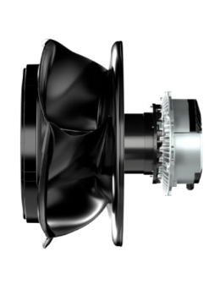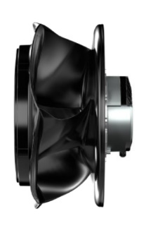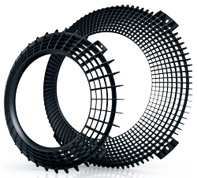
RadiPac EC centrifugal fans RadiPac EC centrifugal fans FlowGrid air inlet grill
Motor-impeller Motor-impeller short version Optional

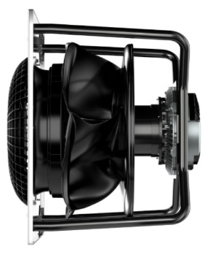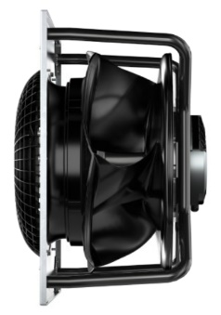
RadiPac EC centrifugal fans RadiPac EC centrifugal fans
Support bracket Support bracket short version
with FlowGrid with FlowGrid

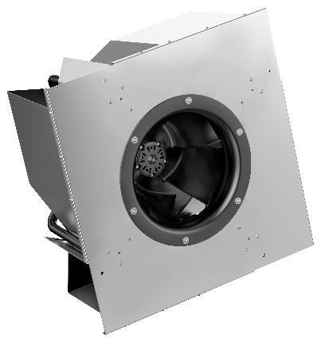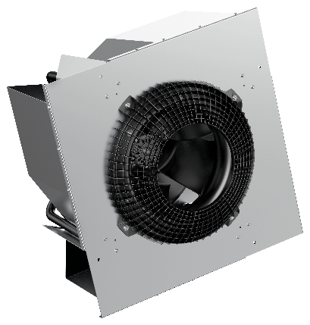
RadiPac EC centrifugal fans RadiPac EC centrifugal fans
Module version Module version
with FlowGrid

See data sheet for dimensions and connections

