Direct-drive single inlet centrifugal fans with backwards-curved high-performance centrifugal impellers with radial diffusers, mounted on a GreenTech EC external rotor motor with integrated control electronics.
Impeller made of aluminum, with backwards-curved, continuously welded, blades; flow-optimized inlet ring made of galvanized sheet steel with pressure test nipple.
Motor impeller statically and dynamically balanced on two planes to balancing grade G 6.3 (motor size 200 to balancing grade G 4.0) in accordance with DIN ISO 1940.
GreenTech EC external rotor motors achieve or exceed the efficiency specifications in accordance with efficiency class IE5 (IEC TS 60034-30-2:2016), magnets with no rare earths, maintenance-free ball bearings with long-term lubrication, theoretical nominal service life of at least 40,000 hours of operation.
Soft start, integrated current limitation,respectively 3~380-480 V, 50/60 Hz. Fan can be used with all standard power supply networks with unaltered air performance. Integrated electronics, low-noise commutation logic; 100 % open-loop speed control; all fans have an RS485/MODBUS RTU interface, and do not need to be installed with shielded cables.
Terminal box made of aluminum with easily accessible connection area, environment-resistant cable glands.

Version for wall mounting:
Support bracket, sizes 355 and 400 with size 150 motor as ready-to-install support bracket intended for wall mounting. Support bracket made of bent round bar steel or round tube, welded and coated in black. Mounting plate and inlet ring made of sendzimir galvanized sheet steel.

Version for floor mounting:
Cube design, sizes 560 and 630 with size 200 motor as ready-to-install cube design intended exclusively for floor mounting. Struts made of extruded aluminum sections connected to die-cast corner plates, nozzle plate and inlet ring made of sendzimir galvanized sheet steel, motor mounting plate made of coated sheet steel. This version is not suitable for wall mounting.

Any work required for isolation from structure-borne noise to be performed by the customer. Fan satisfies the applicable EMC guidelines and requirements with regard to circuit feedback (for specific information, see the respective data sheet). Documentation and marking conform to the applicable EU Directives.
Reliable performance data, air performance measurements on intake-side chamber test rig according to ISO 5801 and DIN 24163, noise measurements in anechoic rooms according to DIN EN ISO 3745.

Integrated protective devices:
- Alarm relay with zero-potential change-over contacts (250 V AC, 2 A, cos φ = 1)
- Locked-rotor protection
- Phase failure detection
- Soft start of motors
- Mains under-voltage detection
- Thermal overload protection for electronics and motor
- Short circuit protection

Optional:
- Other and specific requirements on request
- FlowGrid air inlet grill:
FlowGrid air inlet grill tailor-made for the fan, to reduce assembly and system-related noise. Grill made of high-grade composite material in one piece, ready for installation and also suitable for retrofitting. Open FlowGrid with additional steel guard grill, black plastic coated, for RadiPac C sizes 355 to 630, suitable for accidental contact protection according to EN ISO 13857.

Technical data:
Fan types __ __ __ __ __ __ - __ __ __ __ - __ __
Air flow q_{V} = ___________________________ m³/h, cfm
Fan static pressure p_{fs} = ___________________________ Pa, in wg
Stat. overall efficiency η_{es} = ___________________________ %
Operating speed n = ___________________________ rpm
Motor type = EC motor
Type of control = 0-100% speed control
Motor efficiency class = IE4
Electrical power consumption P_{ed} = ___________________________ kW
Specific fan power SFP = ___________________________ kW/(m³/s)
Nominal voltage U_{N} = ___________________________ V
Mains frequency f = 50 / 60 Hz
Nominal current I_{N} = ___________________________ A
Ingress protection = IP55
Sound power level L_{W} A(A, in) = _______ / L_{W}A(A, out) = _______ dB(A)
Sound pressure level (at 1 m) L_{p}A(A, in) = _______ / L_{p}A(A, out) = _______ dB(A)
Ambient temperature range T = ____________ to ____________ °C
Fan mass m = ___________________________ kg

Product photo:
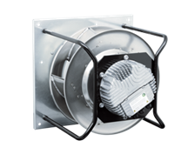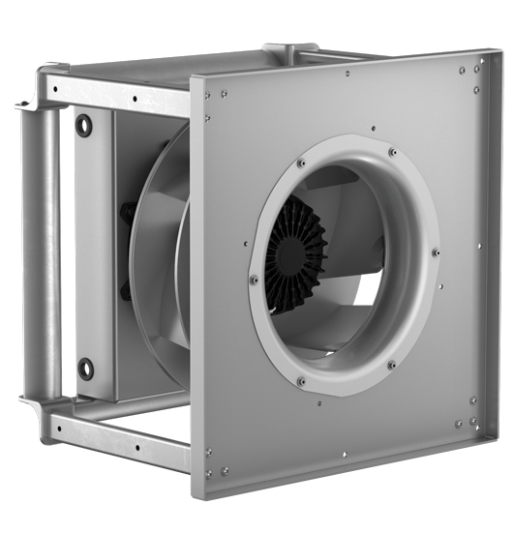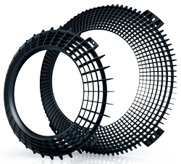
EC centrifugal fans – RadiPac EC centrifugal fans – RadiPac Air inlet grill – FlowGrid
support bracket cube design Optional
Fan sizes 355 - 400 Fan sizes 560 - 630

Refer to data sheet for dimensions and wiring

