Direct-drive single inlet centrifugal fans with backwards-curved high-performance centrifugal impellers with radial diffusers, mounted on a GreenTech EC external rotor motor with integrated control electronics.
Impeller made of aluminum, with 5 backwards-curved, continuously welded, hollow-profile blades; impeller sizes 250 and 280 made of plastic; flow-optimized inlet ring made of galvanized sheet steel with pressure tap.
Motorized impeller statically and dynamically balanced on two planes to balancing grade G 6.3 (from motor size 200 to balancing grade G 4.0) in accordance with DIN ISO 21940.
GreenTech EC external rotor motors achieve or exceed the efficiency specifications in accordance with efficiency class IE5 (IEC TS 60034-30-2:2016), magnets with no rare earth elements, maintenance-free ball bearings with long-term lubrication, theoretical nominal service life of at least 40.000 hours of operation.
Efficiency level of integrated EC motor equivalent to IE5 according to IEC/TS 60034-30-2 (Rotating electrical machines – Part 30-2: Efficiency classes of variable speed AC motors (IE-Code) (IEC/TS 60034-30-2:2016)).
Soft start, integrated current limitation, extended voltage input 1~200-277 V, 50/60 Hz respectively 3~380-480 V, 50/60 Hz. Fan can be used with all standard power supply networks with unaltered air performance. Integrated electronics, low-noise commutation logic; 100 % open-loop speed control; all fans have an RS485/MODBUS RTU interface, and do not need to be installed with shielded cables. All 1~ types have an integrated active PFC (Power Factor Correction) to reduce disturbing harmonic content. Terminal box made of aluminum/plastic with easily accessible connection area with spring-loaded terminals, environment-resistant cable glands, or with external cable (sizes 250 to 280).

Version for wall mounting:
Support bracket, sizes 250 to 560 and 630 to 800 with size 150 motor as ready-to-install support bracket intended for wall mounting. Support bracket made of bent round bar steel or round tube, welded and coated in black. Mounting plate and inlet ring made of sendzimir galvanized sheet steel.

Version for floor mounting:
Cube design, sizes 630 to 1000 from size 200 motor as ready-toinstall cube design intended exclusively for floor mounting. Struts made of extruded aluminum sections connected to die-cast corner plates, nozzle plate and inlet ring made of sendzimir galvanized sheet steel, motor mounting plate made of coated sheet steel. This version is not suitable for wall mounting.

Any work required for isolation from structure-borne noise to be performed by the customer. Fan satisfies the applicable EMC guidelines and requirements with regard to circuit feedback (for specific information, see the respective data sheet). Documentation and marking conform to the applicable EU Directives.
Reliable performance data, air performance measurements on intake-side chamber test rig according to ISO 5801 and DIN 24163, noise measurements in anechoic rooms according to DIN EN ISO 3745.

Integrated protective devices:
- Alarm relay with zero-potential change-over contacts (250 V AC, 2 A, cos φ = 1)
- Locked-rotor protection
- Phase failure detection
- Soft start of motors
- Mains under-voltage detection
- Thermal overload protection for electronics and motor
- Short circuit protection

Optional:
- Other and specific requirements on request
- FlowGrid air inlet grill:
FlowGrid air inlet grill tailor-made for the fan, to reduce assembly and system-related noise. Grill made of high-grade composite material in one piece, ready for installation and also suitable for retrofitting. Open FlowGrid with additional steel guard grill, black plastic coated, for RadiPac sizes 355 to 630, suitable for accidental contact protection according to EN ISO 13857.

Fan types __ __ __ __ __ __ - __ __ __ __ - __ __
Air flow q_{V} = ___________________________ m³/h, cfm
Fan static pressure p_{fs} = ___________________________ Pa, in wg
Stat. overall efficiency η_{es} = ___________________________ %
Operating speed n = ___________________________ rpm
Motor type = EC motor
Type of control = 0-100% speed control
Motor efficiency class = IE5 (equivalent or better)
Electrical power consumption P_{ed} = ___________________________ kW
Specific fan power SFP = ___________________________ kW/(m³/s)
Nominal voltage U_{N} = ___________________________ V
Mains frequency f = 50 / 60 Hz
Nominal current I_{N} = ___________________________ A
Ingress protection = IP54
Sound power level L_{W} A(A, in) = _______ / L_{W}A(A, out) = _______ dB(A)
Sound pressure level (at 1 m) L_{p}A(A, in) = _______ / L_{p}A(A, out) = _______ dB(A)
Ambient temperature range T = ____________ to ____________ °C
Fan mass m = ___________________________ kg

Product photo:

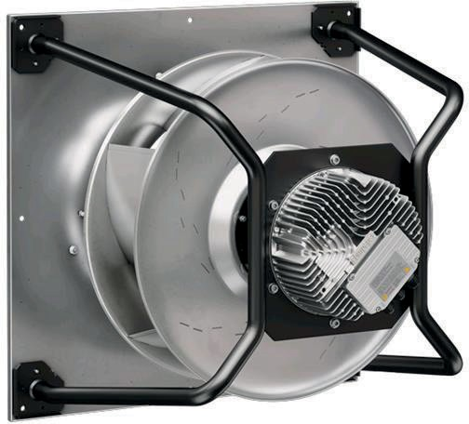 | 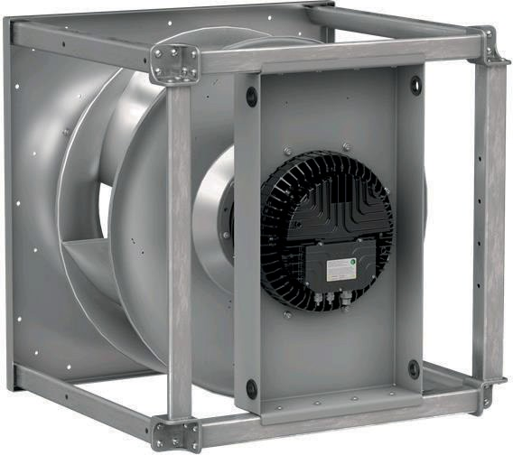 | 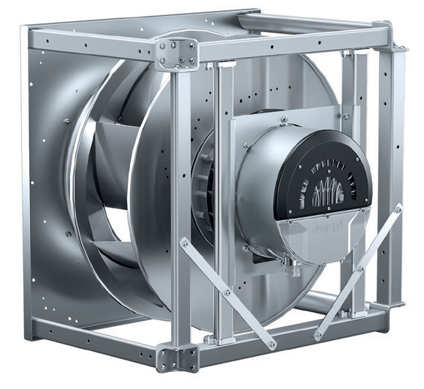 | 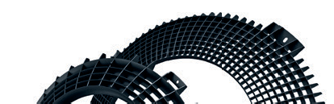  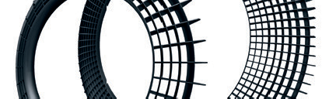  
EC centrifugal fans – RadiPac support spider design  Size 250 - 800 | EC centrifugal fans - RadiPac  cube design  Size 630 - 1000 | EC centrifugal fans - RadiPac  cube design  Size 710 - 800 | pre-direction grid - FlowGrid  Optional

Refer to data sheet for dimensions and wiring

